.

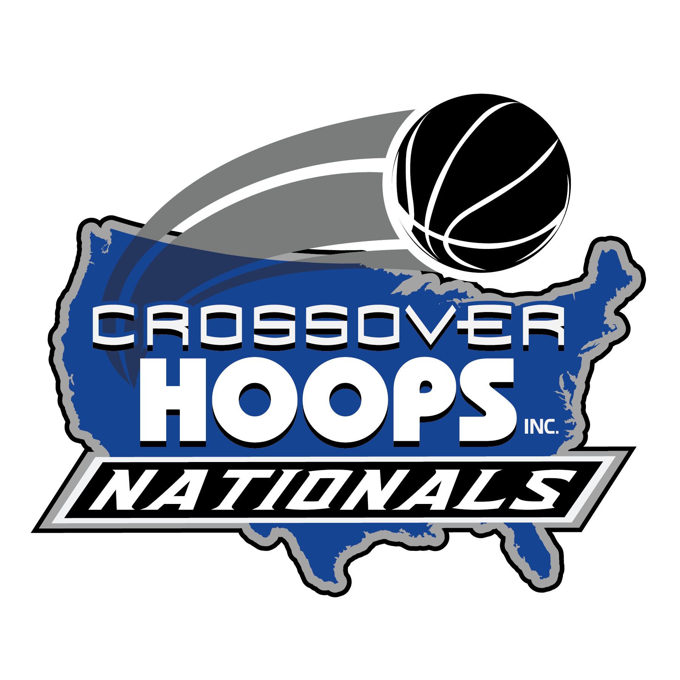
Dear Coaches/Directors:
CONGRATULATIONS! You have qualified to participate in the 2026 Crossover Hoops Nationals. We are excited to officially invite your program to compete in this year’s tournament.
Boys Nationals:
📅 Friday–Sunday, July 10–12, 2026
📍 Boyds, Maryland
Girls Nationals:
📅 Saturday–Sunday, July 11–12, 2026
📍 Ellicott City, Maryland
Why Crossover Hoops Nationals?

- Play local! Beat the rising gas prices.
- Affordable team fees
- Family-friendly admissions
- Free parking
- All games under one roof
- Schedule-friendly format
- Access to top local attractions including Washington DC, Six Flags, Rio Center, Clarksburg Outlets, and much more…

For more information, please contact:
Steve Pacheco: (301) 343-0181, steve@crossoverhoopsinc.com
Shawn Stankiewicz: (610) 763-6896, shawn@crossoverhoopsinc.com

We look forward to hosting you and your team this summer!
Crossover Hoops Inc.
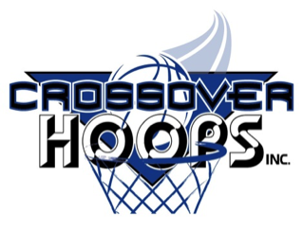
www.crossoverhoopsinc.com

